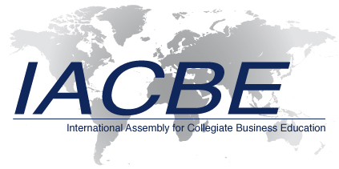

March 23, 2017

Kansas Office of the Secretary of State
Memorial Hall, 1st Floor
120 S.W. 10th Avenue
Topeka, KS 66612-1594

RE: Business Entity 2525798

To Whom It May Concern:

Please find enclosed the amended Articles of Incorporation for the International Assembly for Collegiate Business Education (IACBE), which change the name of our corporation as well as some of the information contained in the various articles. According to our records, the IACBE’s original Articles of Incorporation were accepted on September 29, 1997. We would like these amended Articles of Incorporation with our revised name to be effective immediately, and we have included the $20.00 filing fee.

Please contact our Director of Finance, Kim Caedo, at 913-631-3009 or kimcaedo@iacbe.org if you have any questions or need additional information.

Respectfully,
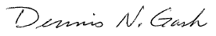

Dennis N. Gash
President

Encl.

