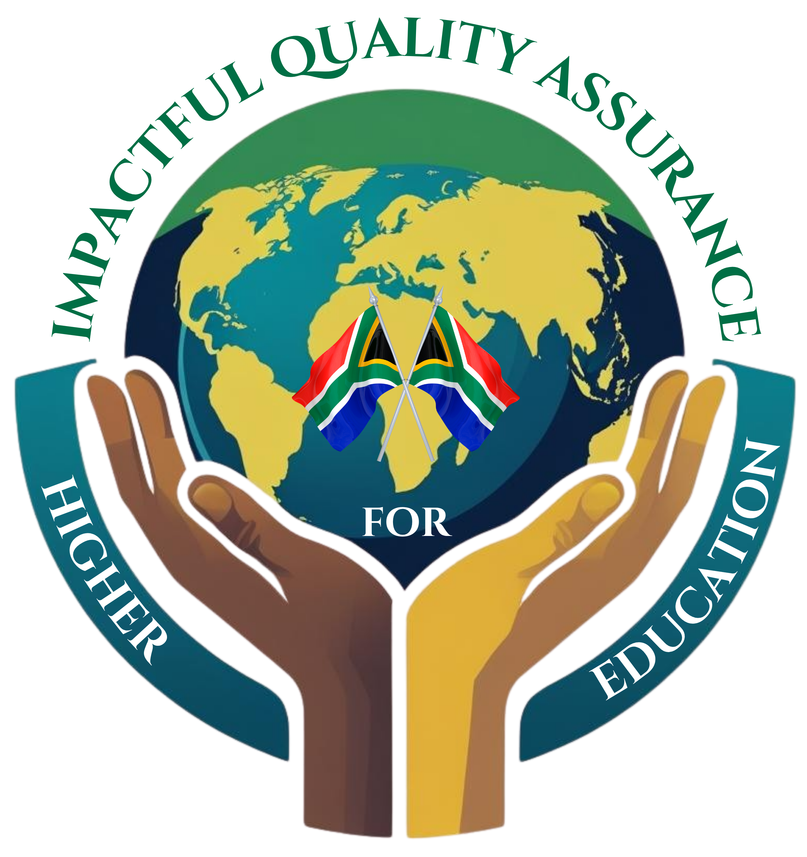

Application form for financial support to attend
INQAAHE Biennial Forum 2026

Quality Assurance as an impactful tool for Tertiary Education
today and tomorrow
Sun City, Northwest Province (South Africa)
February 3-6, 2026

INQAAHE members wishing to apply for financial support from the Network to attend the Biennial Forum 2026 should complete the following application form.

It is important to know that:
- Total funding is limited to 10,000 USD.
- Funding is restricted to applicants from least developed/low-income countries and middle-income countries (as categorised by the World Bank and the United Nations);
- To ensure equitable distribution of funds among a broad pool of members, and considering the different country categories, individual grants for applicants from middle-income countries are capped at 1,000 USD per recipient.
- Priority will be given to Full Members from least developed/low-income countries.
- Funding for applicants from least developed/low-income countries should cover Forum registration fees, travel arrangements (flights) and accommodation, with evidence of expenses required pre-Forum to ensure accountability and proper allocation of funds.
- Funding for applicants from middle-income countries should cover Forum registration fees and accommodation only, with evidence of expenses required pre-Forum to ensure accountability and proper allocation of funds.
- Consideration of regional coverage in funding distribution will be taken into account to ensure equitable access to funding.
- Applicants cannot be funded two years in a row but are welcome to apply in subsequent years. Priority is given to applicants that have not recently received funding assistance.
- Funding decisions made by the INQAAHE Board are final and not subject to appeal.
- Funding will be distributed to the shortlisted applicants prior to the Forum. Reimbursement will be required for no-shows.

Applications need to be sent to secretariat@inqaahe.org by October 15, 2025, for full consideration.

Date of filling:
1. Name of applying agency (indicate if it is member of a regional network).
2. Contact details (address, email, website, etc.).
3. Personnel involved (provide name and short CV).
4. Describe the learning objectives that you would like to achieve by attending the Forum.
5. Indicate the expected benefits for the applicant in terms of professional development and for the applicant’s organization/country.
6. Budget for the activity. Quotations should be provided in the form of an estimate made by a third party such as a travel agency). Individual grants for applicants from middle-income countries are capped at 1,000 USD per recipient.
7. Amount requested for funding.
8. Other information.

